Roles and Responsibilities of Bench Staff For U5-U9 Teams

Bench Staff Position | Required Qualifications | Roles and Responsibilities
Head Coach | - Respect in Sport (RiS) - Activity Leader  - Gender Identity & Expression Course  - Hockey University – Planning a Safe Return to Hockey  - Rowan’s Law Resource Review & Acknowledgement  - NCCP Coach 1 Intro to Coach  - Require a police check | - Collaborate with assistant coach to organize, plan, and conduct both practices and games (refer to helpful resources below for age appropriate practice plans/ skills development)  - The number one responsibility of the coach and his or her staff is to provide a safe environment for their players.  - Attending coaches meeting in October  - Set-up/ take-down of half-ice boards and nets  - Bringing pucks
Assistant Coach | - Respect in Sport (RiS) - Activity Leader  - Gender Identity & Expression Course  - Hockey University – Planning a Safe Return to Hockey  - Rowan’s Law Resource Review & Acknowledgement  - NCCP Coach 1 Intro to Coach  - Require a police check | - Collaborate with head coach to organize, plan, and conduct both practices and games. Shared responsibility in maintaining a safe environment for their players (refer to helpful resources below for age appropriate practice plans/ skills development)  - Attending coaches meeting in October  - Set-up/ take-down of half-ice boards and nets  - Bringing pucks
Trainer | - Respect in Sport (RiS) - Activity Leader  - Gender Identity & Expression Course  - Hockey University – Planning a Safe Return to Hockey  - Rowan’s Law Resource Review & Acknowledgement  - HTCP Level 1  - Require a police check | - Safety, both on and off the ice is the trainer’s primary responsibility and top priority at all times.  - Trainers kit will be provided by BBMHA. Ensure trainers kit is returned at end of season to BBMHA Equipment Coordinator.  - Trainers are to be present with trainer's kit to both games and practices. Please communicate with Head coach if unable to attend arena for scheduled ice times so coverage of alternate trainer can be arranged.  - Responsible for collecting completed Medical Information Sheet (Forms BBMHA website) for all rostered players. Completed forms to be kept within the trainer's kit.  - Coordinate safe return to play as identified in Trainer HTCP Level 1.  - Trainer to create an Emergency Action Plan (will be reviewed at coached meeting)
Manager | - Respect in Sport (RiS) - Activity Leader  - Gender Identity & Expression Course  - Hockey University – Planning a Safe Return to Hockey  - Rowan’s Law Resource Review & Acknowledgement  - Require a police check | - The Team Manager is a central figure in creating the flow of communication – not only within the team (players, parents and coaches), but between the team and all support systems.  - Responsible for scheduling games, applying for jamborees/ festivals (minimum 1 jamboree/ tournament per season), team finances (payment of game officials with allotted funds from BBMHA) setting up time clock
Parent Rep | - Require a police check | - Advocates for team members/ parents relating to concerns/ questions for the duration of hockey season. Please implement the 24-Hour Rule: When an issue occurs and a party has a resulting complaint to make or issue to be resolved, they are asked to wait 24 hours, then put the issue in writing and submit it to the appropriate party.  - All complaints can be forwarded to complaints@blythbrusselsminorhockey.ca.
On-Ice Volunteer | - Require a police check
*All qualifications must be registered with the OMHA
** Any on-ice bench staff/ volunteers must wear a helmet

U9 and Below Ontario Minor Hockey Association (OMHA) Game Play Guidelines

Age  Group/ Team | Games Scheduled | Half or Full Ice | Score Kept | Icing/ Offside/ Penalties indicated | Shift Length | Game Sheet | Official of Game | Jamboree or  Tournament | Goalie position | Type of Puck to be used
U5  (Preschool) | The FUNdamental stages of Hockey Canada’s Long-Term Player Development (LTPD) Model serves as the foundation upon which the entire minor hockey association is built. Youngsters at every level of play benefit from getting the “right start” in the game and it is crucial in building the skills of house league and competitive players alike. Children learn through participating in practice drills and informal modified games which forms the basis of Long-Term Player Development (LTPD)  Objective: Providing a safe environment for the introduction of fundamental skills. Developing an understanding of basic teamwork through structured activities and game-like situations. Introducing participants to fair and cooperative play. Refining basic motor patterns and building self-confidence. Providing an environment that challenges individuals positively and rewards the participants. Providing opportunities to build a lifestyle of fitness and activity. Season consists of practice play, no scheduled games.
U6  (Jr. Initiation)/ U7  (Sr. Initiation) | Yes | Half | No | No | No greater than 2 min, buzzer notifies end of shift* | Optional | Bench Staff | Jamboree** | Rotated with all on ice players | Blue
U8  (Minor Novice)  7 yrs old (as of Dec 31st) | Yes | Half | No | No | No greater than 2 min, buzzer notifies end of shift* | Optional | Minimum 1 Official | Jamboree** | Rotated with all on ice players*** | Blue
U9  (Novice)  8 years old (as of Dec 31st) | Yes | Half ice for first half of season, transition to full ice Jan 15 or later | No | Icing/ Offside-No  Penalties- Yes | No greater than 2 min, buzzer notifies end of shift* | Optional | Minimum 1 Referee half ice, 2 Officials full ice | Jamboree** | Goaltender in full goalie equipment | Black
*All players should have the same opportunity to contribute, regardless of skill or ability. A coach’s responsibility is to develop all players. Shortening of the bench in an attempt to win games is not permitted. All players and goaltenders should receive fair and as close to equal as possible ice time.
**A jamboree is designed to engage players in a fun environment; players come together and are placed onto teams. Games may or may not be competitive and the emphasis is on fun and fair play. A tournament is a schedule of games played among three or more teams, which follows a set schedule and leads to a winner.
*** Goalie equipment is available for use by U8 team. It is not mandatory to have a goalie dressed for a game, but BBMHA would like to encourage interest in goaltending position growth.
Mouthguards are mandatory for all on ice rostered players

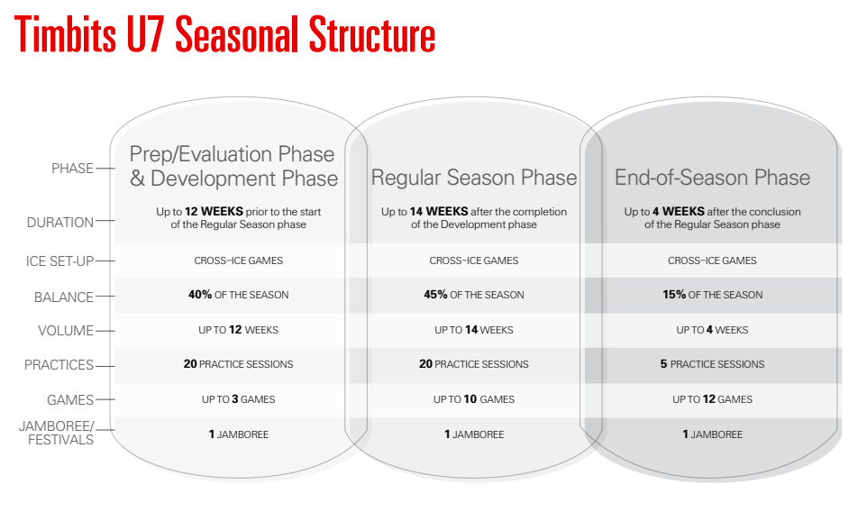

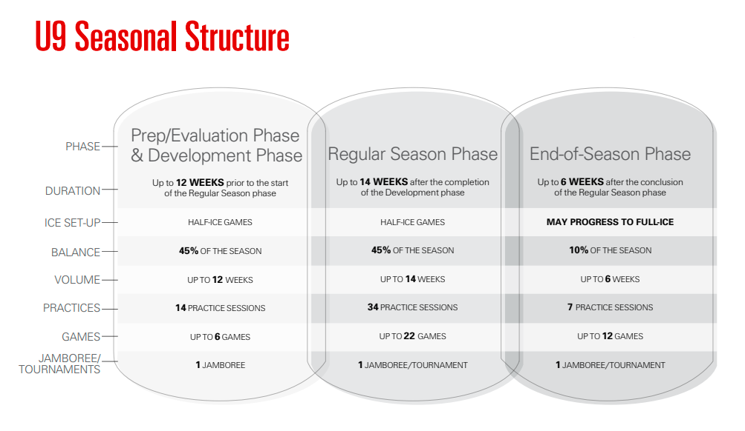
There are NO playoffs in U9 hockey and below
U9 players can transition to full-ice hockey January 15 or later

Surrounding Hockey Centres for Game Scheduling

Bayfield Clinton Hensall Seaforth- Mid-Huron Huskies- mhhuskies.ca
Goderich- Goderich Sailors- goderichminorhockey.ca
Howick- Howick Hornets- howickminorhockey.com
Wallace- Wallace Sabres- wallacesabres.com
Listowel- Listowel Cyclones- listowelminorhockey.ca
Monkton Milverton- Central Perth Predators- centralperthminorhockey.ca
Mitchell- Mitchell Meteors- mitchellminorhockey.com
Wingham- winghamminorhockey.com
Exeter- South Huron Sabres- southhhuronminorhockey.ca
Zurich- Zurich Thunder- zurichminorhockey.ca

Optional Jamborees/ Festivals

Wallace Fun Days- January
Blyth Brussels Jamboree- February
Wingham Jamboree- March
South Huron Jamboree

Helpful Resources for Coaching Staff

- Hockey Canada Network www.hockeycanadanetwork.com
- Drill Hub www.hockeycanada.ca/en-ca/hockey-programs/drill-hub
- Ontario Minor Hockey Association www.omha.net

Good to Know

- U5 players receive Tim Bits Jersey and socks at beginning of the year to be kept
- Respect in sport is required to be done once by every bench staff and player.
- BBMHA Apparel available for purchase mid-October. Game socks are to be purchased by players aged U6 and higher
- No-cost Specialty Clinics available to members throughout season, details can be found on BBMHA website
- Power Skating offered, registration and payment separate from BBMHA
- Goalie equipment available to members interested in trying goaltender position. Please reach out to Equipment Coordinator equipment@blythbrusselsminorhockey.ca
- Skills locker contents (tires/ stepping boards/ pucks/ pylons etc.) can be used for practices. Ensure all equipment is returned to locker following practice. Locker keys can be located in the referee rooms in both Blyth and Brussels arenas.

